# 开发目的

飞行棋是常见的幼儿游戏，对幼儿身心发展具有重要意义，它由棋盘，棋子，骰子三部分组成，飞行棋游戏从设计的角度出发，主要的目的在于以下几个方面：逻辑能力训练，锻炼幼儿的注意力与观察力，以及社会性的发展，包括规则意识，竞争与合作意识，对待输赢的关系。三是数学逻辑训练。

# 3.1 Implementation Method相关技术介绍

通过之前的介绍我们了解到AR技术有很多实现方法，其中之一就是比如：

1，通过 识别图 扫描

通过识别图来显示模型的方式，可以通过上传图片到Vuforia 官网数据库中，生成资源包下载并导入到unity中。在AR开发过程中，很多人会觉得将识别图上传到官网数据库然后再从数据库下载这个过程  难免有些繁琐。第二种方式就是在使用时实时创建识别图，也就是自定义目标识别图。打开摄像头开始扫描后，以扫描到的某一固定场景作为识别图，实现这一步骤的方法就是使用摄像头进行拍照，这时就需要一个触发拍照的指令，用一个Button来实现。我们扫描到我们要自定义的识别图时，按下Button，然后识别图创建完成，扫描该识别图，模型出现。另外，自定义识别图是不支持虚拟按键的。由于飞行棋需要标准的棋盘,但是此方法不能保证扫描的棋盘标准化，由于本游戏需要一个大小比例标准的棋盘，因此 本应用采用利用上传到Vuforia数据库然后下载资源包的方式进行自定义图片的识别。The data stream of Vuforia SDK is divided into four modules: inputting, database, tracking and matching and render output [32].

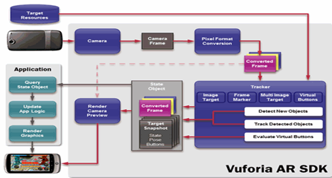

Fig. Data flow diagram of Vuforia SDK [ ]

# 3.2 Game Design

怀念小时候玩过的飞行棋吗?如今我们把它搬到了手机上。基于AR增强现实技术，“AR飞行棋”告别了昔日的凌乱零件，只需一张识别图，拿起手机一扫，便可将虚拟的棋盘融入到现实世界中，让你透过手机体验基于真实世界的虚拟交互。

AR飞行棋的特色：虚实结合的AR技术，让你随处身临其境。下图为飞行棋的棋盘。

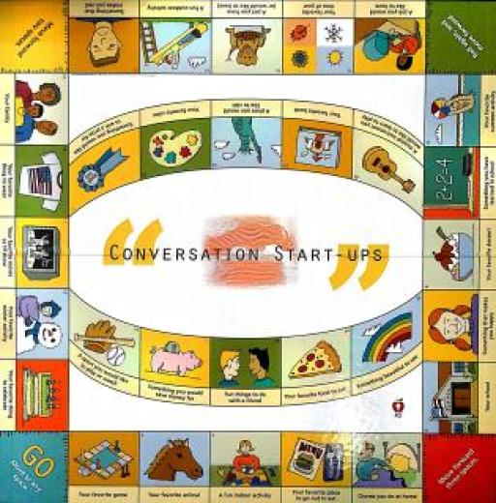

Fig.23 飞行棋棋盘（识别图）

In this project, we made a board game that can allow multiplayers to play in a combination of realistic and virtual space. In this Board Game, there are 3 characters with different colors and several buttons to control the characters.

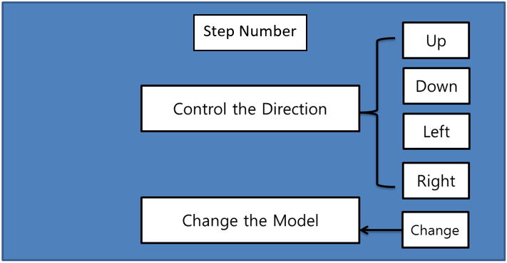

Fig.24 the game Flowchart

A player has played on a specially designed board. The games have been played in most societies and cultures throughout history [4]. Especially the games that are based on strategy placed on a pre-marked surface according to a set of rules [4]. Molla et al. have been studies how to transform actual game into game of Augmented Reality by using a simple webcam [5]. For mobile AR games are several interaction studies like the potential of interaction based on finger movement via camera [6]. The Sphero [7] focuses on both tangible interfaces and physical around players and increases enjoy ability and immersion. Vancouver Maneuver [8] has created a cooperative board game experience by using Augmented Reality for mobile devices. The game provides both digital and analogue board game design like hybrid game design approach.

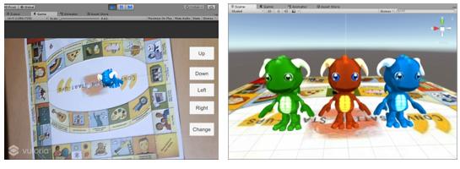

(a) Beginning the game (Game Scene) (b) Game Models

Fig.25 Results of designed Game

# 3.3 Project Implementation

The Experimental environment for this development is Intel(R) Xeon(R)CPU E3-1240 v3 @3.40GHz 3.40GHz, RAM 8GB with window 10 and using software include version 5.5.2f1 personal (64bit) of Unity3D and vuforia unity-6-2-10 unity package for AR. We have implied the game in a mobile device such as an android. Fig. 2 shows the result of designed game.

(Qualcomm)是提供Unity插件开发AR产品的AR公司。利用上传识别图到Qualcomm Vuforia资源库。

1.新建工程并将Vuforia插件导入Unity

2.将图片上传到官网，下载相应的图片数据包，高通(Qualcomm Vuforia)会为识别图评测识别度（星级），在项目中识别图最少要三星。

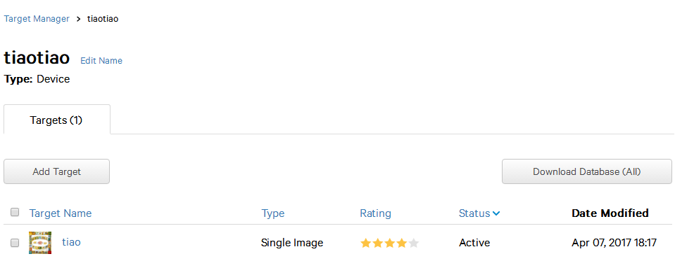

Fig.26

3.将原始场景中的MainCamera删除，并拖入vuforia预制件中的ARCamera，ImageTarget

4.导入三个模型到层级视图Hierachy中

5.在ARCamera下面的VuforiaBehaviour下点击OpenVuforiaConfiguration,输入LicenseKey。

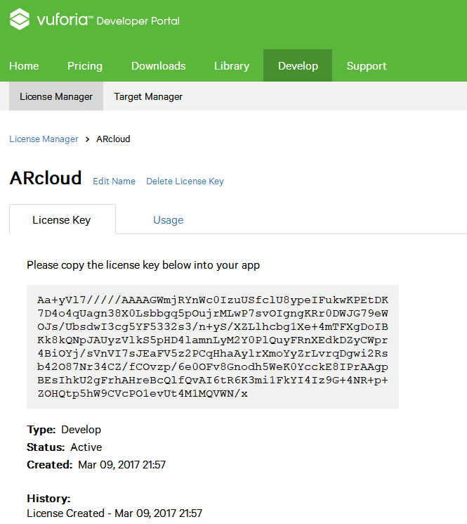 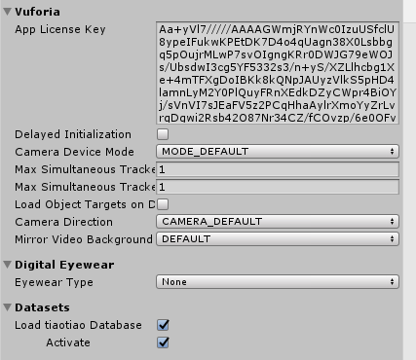

1. (b)

Fig.27 add key

然后将ImageTarget的类型设置为Predefined（如果是用户自定义则为UserDefined）。

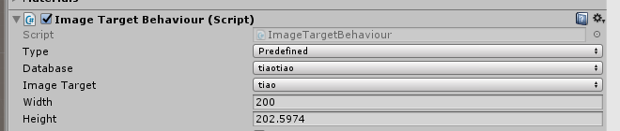

Fig.28 choose the database

6. 写脚本，ImageTarget 上边的AR脚本DefaultTrackableEventHandler.cs中，可以通过状态 + 控制，完成识别后的切换，如果想识别多张图，可以创建多个ImageTarget。

TrackableBehaviour.Status.DETECTED//检测到TrackableBehaviour.Status.EXTENDED_TRACKED//延伸跟踪

TrackableBehaviour.Status.NOT_FOUND//未找到

TrackableBehaviour.Status.TRACKED//跟踪中

还需要有控制角色的脚本名字叫做Move.cs,挂到player下，然后将三个模型预制体拖到脚本变量上。

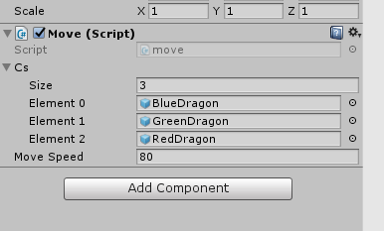

Fig.29

for (int i = 0; i < 3; i++)

{

Cs[i].SetActive(false);

}

modelId_ = ran.Next(0, 3);

C_now = Cs[modelId_];

C_now.SetActive(true);

C_now.transform.parent = this.transform;

设置UI

本游戏画面共有5个按钮用来调整方向，和一个文本显示框用来显示步数。

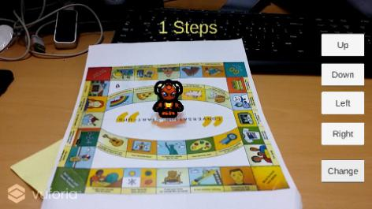 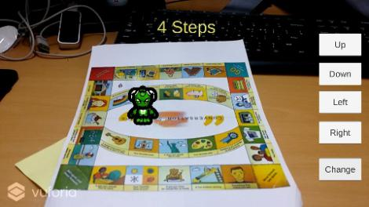 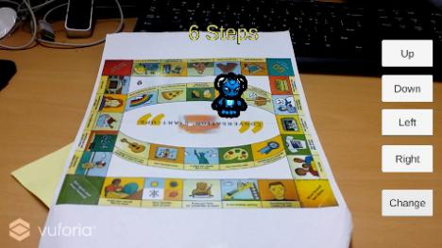

Fig.30 游戏运行画面

3.4 Conclusion

本应用针对的用户人群是学龄前儿童，通过这个应用，可以训练儿童的逻辑能力，锻炼幼儿的注意力与观察力，以及有利于儿童社会性的发展，包括规则意识，竞争与合作意识。

A Ludo Game

Ludo game or named as Flying Chess is a common toddler game, which has great significance on the physical and mental development of young children. It consists of three parts: chessboard, chess pieces, and dice. The main purpose of the development of Ludo game are: training logical ability, exercise young children's attention and observation. The second is social development, including awareness of rules, competition and cooperation, and the perspective on winning or losing. The third is mathematical logic training.

3.1 Implementation Method

Through the previous introduction in Chapter 2, we learned that there are many ways to achieve AR technology, one of which is the three-dimensional registration technology, such as: Through the identification map. The way to display the model by recognizing the map can be done by uploading the image to the Vuforia website. The resource package can be downloaded and imported into the unit. In the AR development process, many people will feel that uploading the identification map to the official website database and then downloading it from the database is inevitably complicated. The second way is to create a recognition map in real time when used, that is, a custom target recognition map. After opening the camera to start scanning, using a fixed scene as a recognition map, the method to achieve this step is to use the camera to take a picture. At this time, an instruction to trigger the photographing is needed and a button is used to implement the photographing. When we scan to the identification map that we want to customize, press the button, and then the identification map is created, scan the identification map, and the model appears. In addition, custom identification maps do not support virtual keys. Since flying chess requires a standard board, this method does not guarantee the standardization of the scanned board. Since this game requires a checkerboard with a standard aspect ratio, this application uses the method of uploading to the Vuforia database and then downloading the resource pack to identify custom images.

The data stream of Vuforia SDK is divided into four modules: inputting, database, tracking and matching and render output [32].

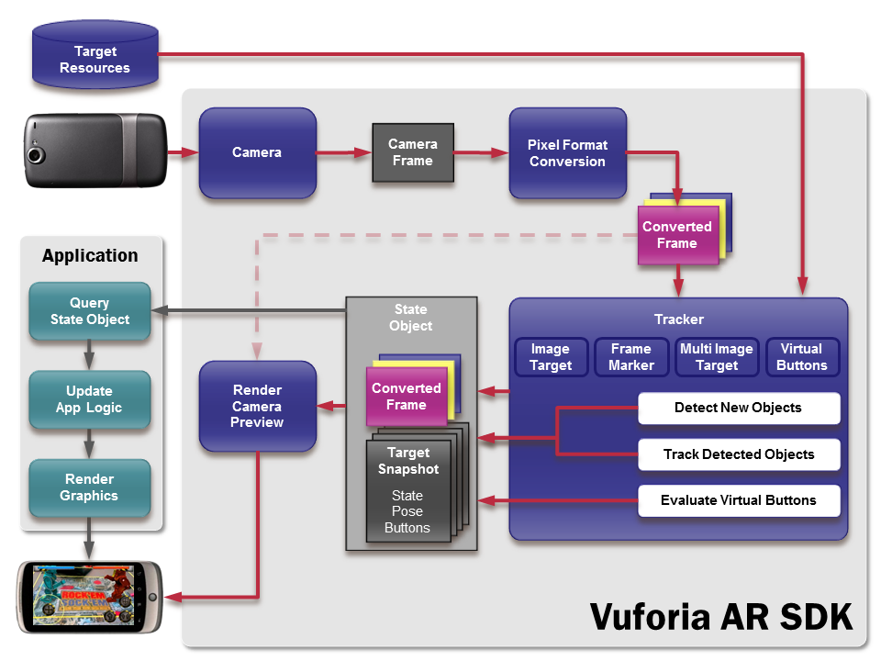

Figure 3-1. Data flow diagram of Vuforia SDK [http://hotdigi.tistory.com/1264 ]

3.2 Game design

We have moved the flying chess that we played when we were young it to the phone. Based on augmented reality technology, "AR Flying Chess" bid farewell to the messy parts, just need to pick up the mobile phone swept the pre-printed recognition map, you can integrate the virtual game board into the real world, the users can directly experience based on AR interaction through the mobile phone. The characteristics of the AR flying chess allows you play it anywhere and anytime. The following figure shows the board for flying chess, it is also the identification map.



Figure 3-2. The board of the game（Identification pic）

As we introduced in the previous sections, AR is the integration of digital information with the user's environment in real time [32]. In this project, we made a board game that can allow multiplayers to play in a combination of realistic and virtual space. In this Board Game, there are 3 characters with different colors and several buttons to control the characters.

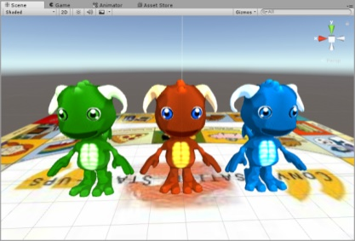

Figure 3-3. Game Models

A player has played on a specially designed board. The games have been played in most societies and cultures throughout history [4]. Especially the games that are based on strategy placed on a pre-marked surface according to a set of rules [4]. Molla et al. have been studies how to transform actual game into game of Augmented Reality by using a simple webcam [5]. For mobile AR games are several interaction studies like the potential of interaction based on finger movement via camera [6]. The Sphero [7] focuses on both tangible interfaces and physical around players and increases enjoy ability and immersion. Vancouver Maneuver [8] has created a cooperative board game experience by using Augmented Reality for mobile devices. The game provides both digital and analogue board game design like hybrid game design approach.

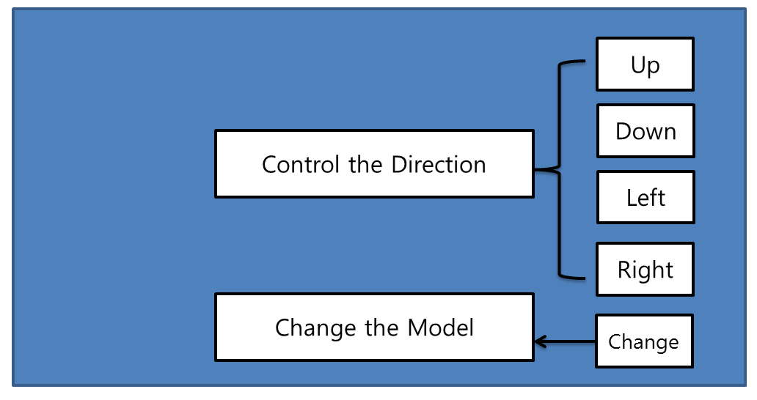

Figure 3-4. The board game Flowchart

3.3 Implementation

The Experimental environment for this development is Intel(R) Xeon(R)CPU E3-1240 v3 @3.40GHz 3.40GHz, RAM 8GB with window 10 and using software include version 5.5.2f1 personal (64bit) of Unity3D and Vuforia unity-6-2-10 unity package for AR. We have implied the game in a mobile device such as an android. Figure 3-5 shows the result of designed game.

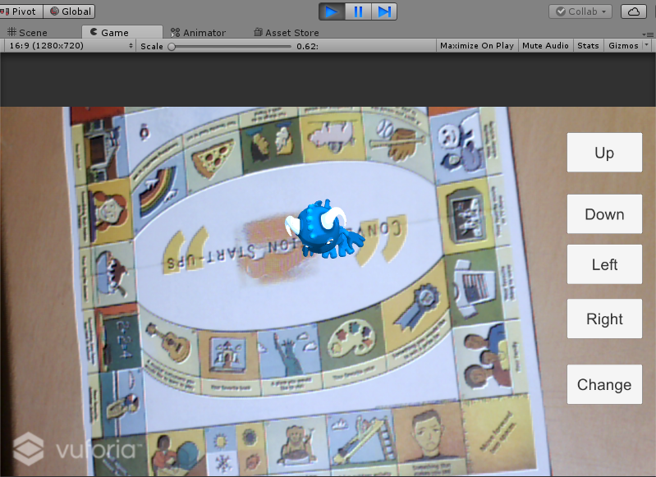

Figure 3-5. Beginning the game (Game Scene)

(Qualcomm) is an AR company that provides the Unity plug-in to develop AR products. Use the upload identification picture to the Qualcomm Vuforia repository.

1. Create a new project and import Vuforia plugin into Unity

2. Upload the identification picture to the Vuforia website, download the corresponding picture data package, Qualcomm Vuforia will identify the degree of recognition for the recognition picture by number of stars, identify the picture in the project at least 3 stars.



Figure 3-6. the identification picture used in this application

3. Delete the MainCamera in the scene and drag it into the ARCamera in the vuforia prefab, ImageTarget.

4. Import three models into Hierachy.

5. Click OpenVuforiaConfiguration under VuforiaBehaviour under ARCamera and enter LicenseKey.



(a) (b)

Figure 3-7. Copy the license key and paste to unity

Then set the ImageTarget type to Predefined (set to UserDefined if it is user-defined).



Figure 3-8. choose the database

6. Write the script. In the default script named Default Trackable Event Handler.cs on the ImageTarget, you can use state + control to complete the switch after recognition. If you want to identify multiple images, you can create multiple ImageTargets.

TrackableBehaviour.Status.DETECTED TrackableBehaviour.Status.EXTENDED_TRACKED

TrackableBehaviour.Status.NOT_FOUND

TrackableBehaviour.Status.TRACKED

You also need to have a script that controls the character called“Move.cs”, hang it on the player object, and then drag the three model prefabs to the script variable.



Figure 3-9. set the move.cs

for (int i = 0; i < 3; i++)

{

Cs[i].SetActive(false);

}

modelId_ = ran.Next(0, 3);

C_now = Cs[modelId_];

C_now.SetActive(true);

C_now.transform.parent = this.transform;

7. Set up the UI. There are 5 buttons in this game screen to adjust the direction, and a text box is used to display the number of steps.



(a)



(b)



(c)

Figure 3-30. Game scenes

3.4 Conclusion

The user population targeted by this application is pre-school children. Through this application, children's logical ability can be trained, their attention and observation can be exercised, and the children's social development can be facilitated, including awareness of rules, competition, and cooperation.